**BUILD FOR INDIA - SIH Internal Hackathon 2025**

**SAMVAAD –** Smart Automated Machine for Voice , Accessibility And Diversity

* **Theme:** SMART AUTOMATION
* **Team Name:**  Syntax Error
* **Team Leader:** Piyush Joshi
* **Team Members:** Tarun Ruwali, Pragati Sanguri ,Harshit Bisht, Nitesh Pandey, Mansi Pandey .

**Problem Statement**

The core problem is the absence of a convenient and empowering technology that gives DHH(Deaf and Hard of Hearing) individuals a "voice" and allows them to navigate and be fully understood in a world that doesn't speak their language.

There is a strong need for a smart automated solution that can instantly convert sign language into text and speech, enabling barrier-free, inclusive, and efficient communication.

**Problem Solution**

The project tackles the most significant barrier faced by DHH individuals which is real-time communication tool that seamlessly translates sign language into text and speech.This empowers them to communicate independently and spontaneously, whether they are at a hospital, a bank, or a casual social gathering and ensures inclusivity and enables barrier-free interaction in everyday life

**FLOWCHART -**

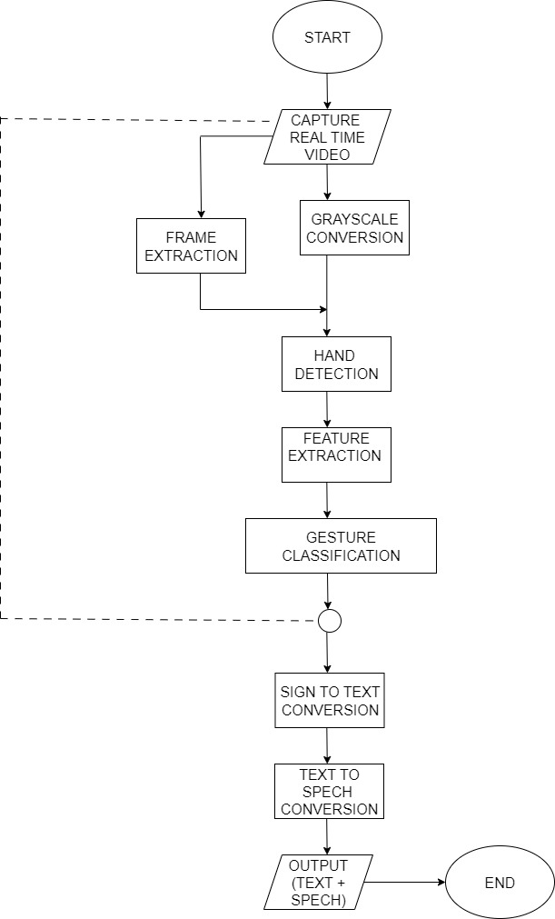

System Architecture

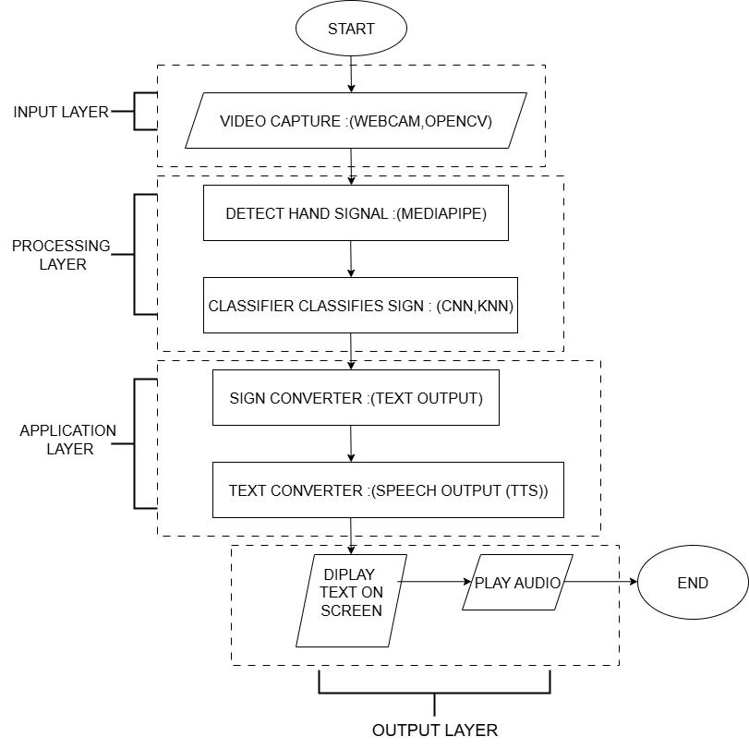

**Tech stack**

●Programming language:

Python

●Computer Vision

OpenCV

MediaPipe

●Handling of coordinates and data:

NumPy

TensorFlow

●Classifiers:

CNN

KNN

●Text to speech (TTS):

pyttsx3

gTTS

Coqui TTS

●UI/UX:

Tkinter

**Research / Early work**

We are building an AI-powered, real-time communication tool that converts sign language into text and speech, covering the gap instantly between the DEAF and HARD OF HEARING .

As lack of real-time communication support creates barriers in education, healthcare, employment, and daily life. Our research aims to address these gaps by building a **lightweight, scalable, and domain-agnostic system.**

**Our prior research** has explored the use of **computer vision and deep learning techniques**—including CNNs, KNNs, and Transformer-based models—for gesture recognition.

As traditional methods such as **human interpreters or manual transcription** are not always accessible, affordable, or scalable , and empowers the DHH community with a true voice, ensuring equal opportunities and barrier-free communication for all .

**By integrating AI with sign language recognition, our solution goes beyond technology .**

**Implementation Plan –**

1. **Requirements analysis-**

**Objective –**

It’s a real time , sign language translator into speech .

**Target group** –

Use in health care , government offices where specially abled people can easily interact with the authorities without any failure .

**Resourses –**

Web cam , ISL dataset of sign language gestures , microphones .

**Software**:

* Python
* Frameworks: TensorFlow / PyTorch
* OpenCV
* KNN/CNN models.

1. **Team Formation & Role Allocation –**

**Computer vision engineering – (Piyush )**

works on detection and recognition of sign language using open cv , media pipe , tensor flow .

**speech engineering – (Tarun , Nitesh )**

integration of text-to-speech (TTS) system for audio output .

**Testing and QA team – ( Harshit , Mansi )**

Real-world testing with signers, debugging latency issues.

**Data Engineering and Deployment - ( Tarun )**

Data processing and annotation .

**Product manager and co-ordinator – (Pragati , Piyush )**

Ensure deadlines, organize sprints, manage communication.

1. **Resource planning**

* Set up of python , open cv , tensor flow ,media pipe and other libraries .
* Development tools – git hub , python IDEs .
* Testing support

**4.Problem statement finalization –**

**Why important ?**

* Signers often face barriers in real time communication .
* Our system directly removes reliance on interpreters

**Feasibility :**

* CNN – extraction of feature of hand points.
* RNN – sequence wise translation of signs .
* NLP - converting into meaningful sentences .
* TTS - final speech output .

**5. Communication & Guidelines**

* **Development Guidelines**:
  + Python coding standards
  + Modular code

Proper API design

* **Documentation**:

* README, technical reports, user manuals.

* Flow diagrams & architecture docs.

**6. Event Day Preparation –**

**Demo Workflow :**

User signs → Camera captures gesture → Model predicts → Text displayed → Voice generated.

**Setup Requirements:**

* Camera setup + laptop + projector/screen.
* Microphone & speaker for live demo.
* **Presentation**:
* Live walkthrough + explanation of model pipeline + future scope.

**7. Hackathon execution –**

**Communicaton and announcements –**

Interactive QA sessions , mini checks .

**Team monitoring –**

Regular check ups to ensure that team members are working actively on their solution .

**Smooth work flow and engagement –**

Feedback loops are maintained where participants can share their challenges, making the event more interactive.

**References -**

* 1. MediaPipe Hands: Real-time Hand Tracking.

[https://developers.google.com/mediapipe](https://developers.google.com/mediapipe%20)

* 1. TensorFlow Documentation.

<https://www.tensorflow.org>

* 1. Smart India hackathon Themes

<https://sih.gov.in/SIH_Themes>

* 1. ***WHO Guidelines on Physical Activity (2020)*** – Importance of need for physical fitness in overall development of children.

<https://www.who.int/publications/i/item/9789240015128>

* 1. Indian Sign Language (LSI)

<https://www.kaggle.com/datasets/prathumarikeri/indian-sign-language-isl>

RESEARCH PAPERS -

* 1. N. C. Camgoz, O. Koller, S. Hadfield, and R. Bowden, “Neural Sign Language Translation,” *(CVPR)*, 2018, pp. 7784–7793.
  2. **Spatial-Temporal Multi-Cue Network for Continuous Sign Language Recognition**  
     Y. Zhou, W. Zhou, H. Li.  
     *AAAI 2021.*